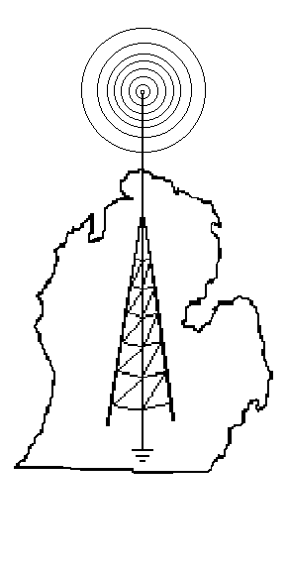
Hillsdale County Amateur Radio Club

K8HRC www.hcarc.com
FIELD DAY

Field Day (FD) is an annual Emergency Communications (EmComm) preparedness exercise where licensed Amateur Radio (“Ham”) operators set up and demonstrate various modes of wireless contact in nonstandard locations. It also serves as a contest to see how many contacts can be made with other FD stations within a 24-hour period and to educate the public about EmComm and Ham radio.

For the past several years, the HCARC has set up our FD station in the Agricultural Education and Exhibits Building (much more popularly known as the octagonal Log Cabin) at the Hillsdale County Fairgrounds. Below are some photos from FD 2004.
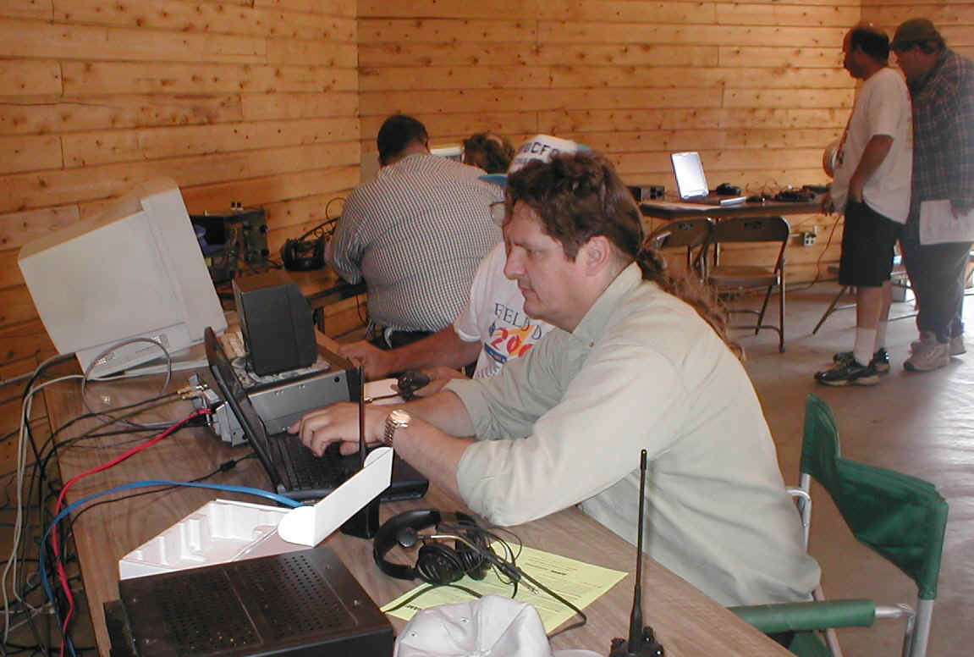
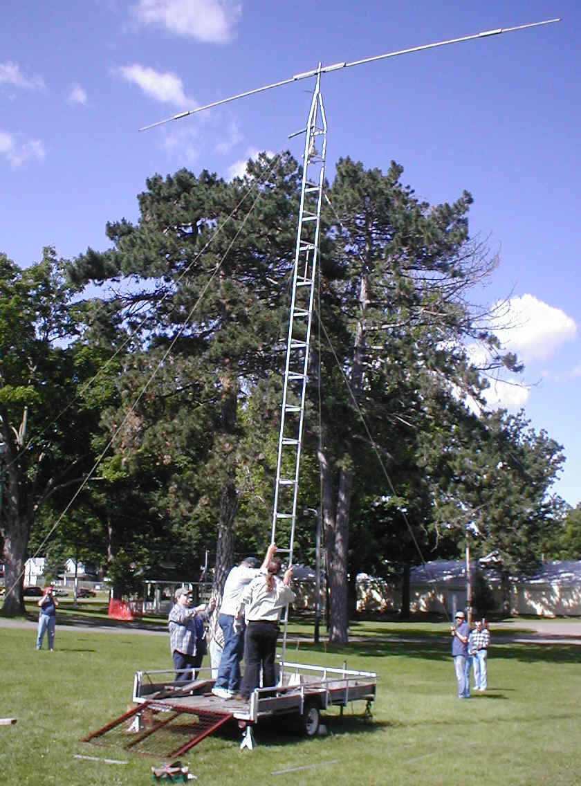
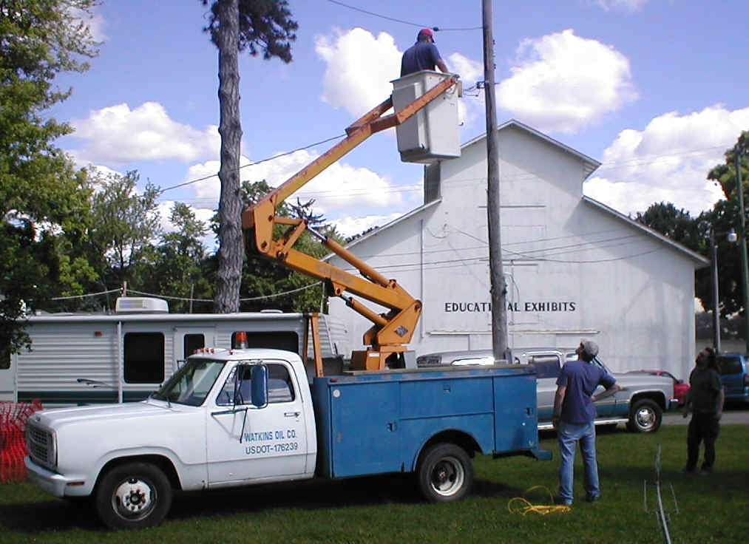
Putting them up - - and putting ‘em to use!

Watkins Oil let us borrow their lift truck so we could transform the old banner-hanging cable strung across the field into an antenna that got great signal reports from across the country! We used a networked computor system to log our contacts and had many visitors and guest operators.

With the increased awareness of the need for Homeland Security and the critical role that EmComm assets play in that service, FD is more vital than ever. Local Public Service and Emergency Services personnel both visit the FD site and actively participate in the preparations and operations.

FD is also an excellent opportunity for any interested members of the general public to gain both knowledge and experience of Amateur Radio. The FD site is Open to the public, there is NO Admission charged (although all Donations are cheerfully accepted!) and anyone, licensed or not, can talk on the Ham bands so long as there is a licensed Control Operator present (& we’ll have plenty).

We've made contacts across the continent and, with some enhancements we're planning for 2005, hope to expand both our range and the number of stations with whom we can communicate. We look forward to your being able to visit us during the 24 hours we'll be in operation (2 p.m. Sat., June 25 through 2 p.m. Sun., June 26) and maybe taking the opportunity to get on the air!

For more information, visit our website.

