Hillsdale County Amateur Radio Club

K8HRC www.hcarc.com
FIELD DAY

Field Day (FD) is an annual Emergency Communications (EmComm) preparedness exercise where licensed Amateur Radio (Ham) operators set up and demonstrate various modes of wireless contact in nonstandard locations. It also serves as a contest to see how many contacts can be made with other FD stations within a 24-hour period and to educate the public about EmComm and Ham radio.

For the past few years, the HCARC has set up our FD station in the Agricultural Education and Exhibits Building (much more popularly known as the octagonal Log Cabin) at the Hillsdale County Fairgrounds. Below are some photos from FD 2003.
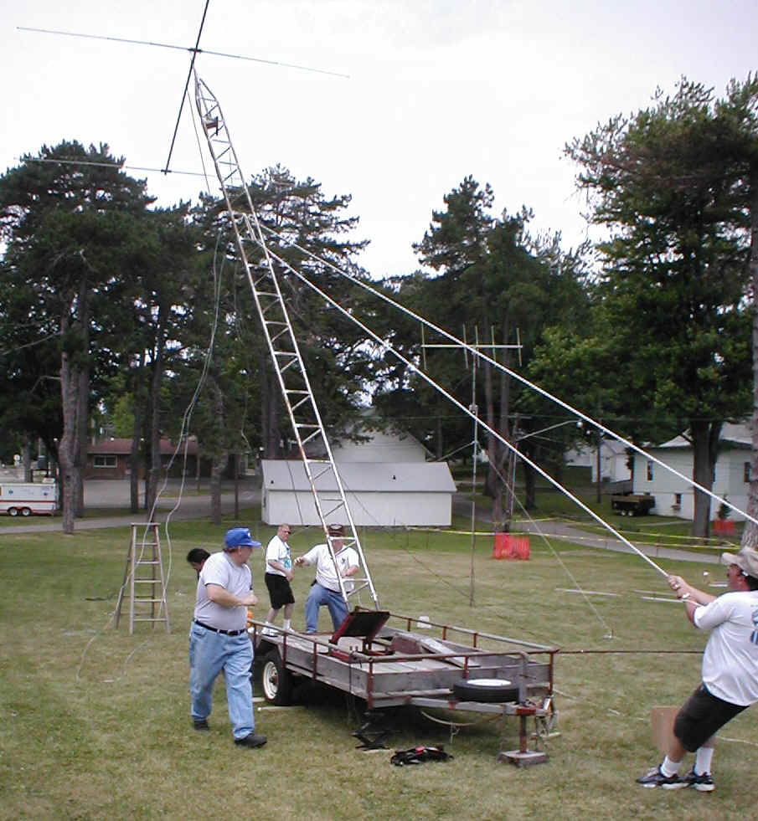
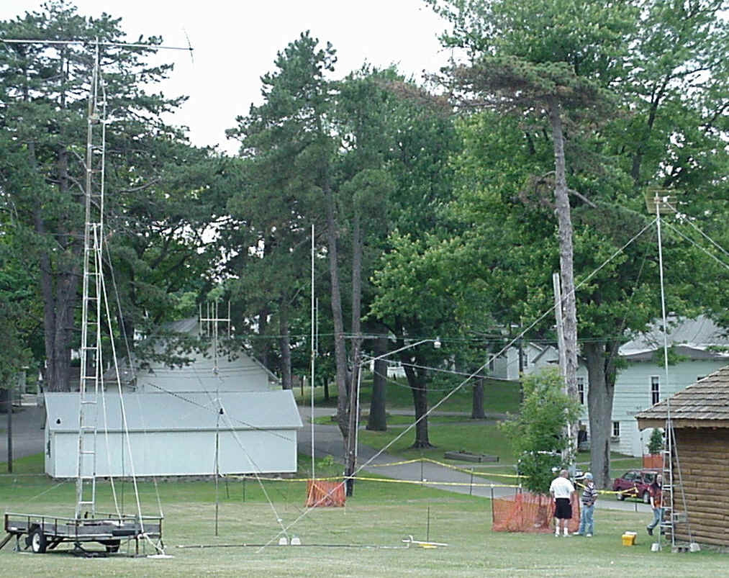
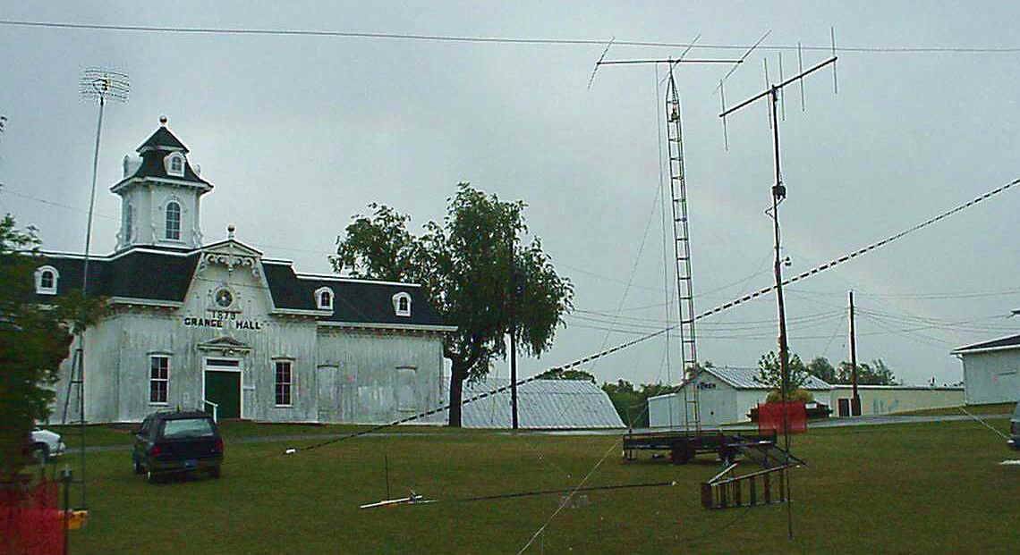

Our "antenna farm". The rainbow after the storm.

Despite getting a late start and having to take a few hours off for a severe thunderstorm passing over us - a good time was had by all and we learned a lot in the process, which is the real purpose for FD. We had a WiFi (wireless Internet connection via Ham radio) demonstration station and used a linked computer network to log our contacts.

With the increased awareness of the need for Homeland Security and the critical role that EmComm assets play in that service, FD is more vital than ever. Local Public Service and Emergency Services personnel both visit the FD site and actively participate in the preparations and operations.

FD is also an excellent opportunity for any interested members of the general public to gain both knowledge and experience of Amateur Radio. The FD site is open to the public, there is no admission charged (although all donations are cheerfully accepted!) and anyone, licensed or not, can talk on the Ham bands so long as there is a licensed Control Operator present.

We've made contacts across the continent and, with some enhancements we're planning for 2004, hope to expand both our range and the number of stations with whom we can communicate. We look forward to your being able to visit us during the 24 hours we'll be in operation (2 p.m. Sat., June 26 through 2 p.m. Sun., June 27) and maybe taking the opportunity to get on the air!

For more information, visit our website or contact:

Pres. Dan Sprow, 437-1410, dsprow@comcast.net

Sec. Peter Cromwell, 283-2223, cromwells@dmci.net

